Tools for Digital Analysis

Installation

Nvivo 11
Step 1: Navigate to www.terpware.umd.edu → Analysis & Modeling → Nvivo 11
Step 2: Login for access and generate a product key. Once completed, click the download link under Installation Notes
Step 3: Scroll to ‘Older versions’ section. Click the link for the version of Nvivo 11 appropriate for your device. The download should begin immediately.
Step 4: Launch the installer (.exe for PC and .dmg for Mac) and install all requirements (Microsoft Visual C++ and Microsoft SQL Server). Depending on what software you use, some conditions might already be satisfied.
Step 5: Once Nvivo 11 is ready to be installed, you will need to close all other applications before hitting ‘Next’
Step 6: Accept the terms in license agreement. Click next and install Nvivo in your Program Files (PC) or Applications (Mac) folder.
Step 7: On the ‘Supplementary Adds-on page,’ Check install NCapture for Chrome. Then click Install to begin the installation. Once finished, check the Launch Nvivo box and click ‘finished.’

NCapture
Step 1: Ensure that you have Google Chrome installed. NCapture is a browser extension for Chrome.
Step 2: Open Google Chrome and click the ‘Apps’ tab on the top left of the browser
Step 3: Use the search bar to find ‘NCapture.’ Click Install. If installation is successful, you will see an icon on the right hand side of the address bar in Google Chrome.
Step 4: To use NCapture on tweets, you will need to create a an account at Twitter.com and log in via Google Chrome.
Step 5: You will also have to authorize NCapture to work with Twitter before you can collect tweets. Run a search on Twitter in Google Chrome and then click the NCapture button. The page will automatically load to an authorization page.

Using NCapture to Collect Tweets
Step 1: With Nvivo open, click ‘Blank Project.’ Name your project & check the ‘Write user actions to project event log.’
Step 2: Return to Twitter.com via Google Chrome and login. Use the search field to look for the text you are interested in. If you would like to pull data from a specific user, navigate to their profile page.Click the NCapture button in the browser window. A confirmation window will pop up.
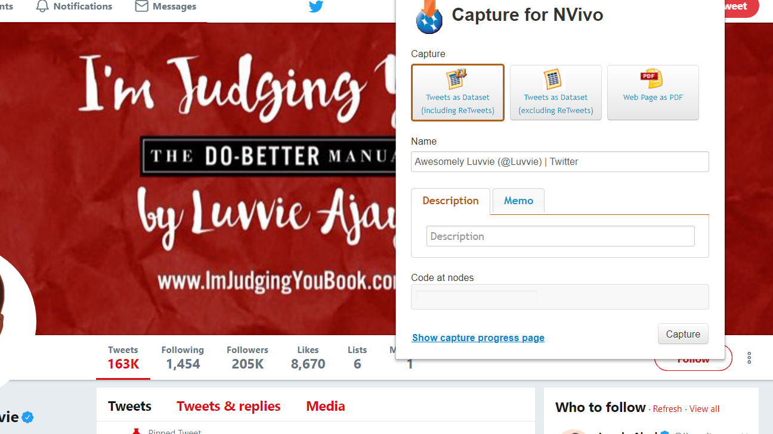
Image above shows the popup window that appears when you click the NCapture button.

Step 3: Choose to import your tweets as dataset (including retweets). Click Capture. Once finished, an NCapture file (.nvp) will show up in your downloads folder.
Step 4: Return to Nvivo. Go to the Import tab and click the NCapture button. Navigate to your downloads folder by clicking ‘Browse’. Select ‘All captures not previously imported’ and the click ‘Import.’ A successful import should reveal a screen like the image below, once you double click on the imported file.

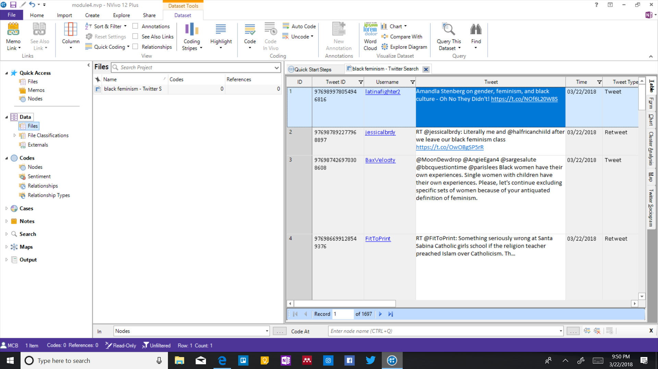
Image is a screenshot of a successfully imported NCapture file of Twitter data.

Accessing AFL-CIO Materials
Step 1: Navigate in your Google Chrome browser to http://aadhum.mith.us/labor.html
Step 2: Click ‘Add Item’
Step 3: Look through the collections and decide which one you find interesting. Once you have chosen, click on the name of the collection.
Step 4: Browse the collection and make sure the materials within it satisfy your research questions (images vs. text).
Step 5: Download the desired image, by right clicking and choosing ‘Save as….’
Step 6: Return to Nvivo and go to the ‘Import’ tab. Click ‘Files’ and import the desired images from where you saved them.

Tutorials

Nvivo
- Getting Started Guide (PDF) - http://www.qsrinternational.com/nvivo/free-nvivo-resources/getting-started
- Lynda.com (Video) - https://www.lynda.com/NVivo-tutorials/How-use-exercise-files/530082/562637-4.html

NCapture
- General (Web) - http://help-nv11.qsrinternational.com/desktop/procedures/import_web_pages.htm
- Twitter (Web) -
  - http://help-nv11.qsrinternational.com/desktop/concepts/approaches_to_analyzing_twitter_data.htm
  - http://help-ncapture.qsrinternational.com/desktop/topics/capture_from_twitter.htm

AFL-CIO Archive
- Download Images (Video) - https://youtu.be/yb2bF6Auoc4

You can also download a 14 day free trial version of Nvivo at https://www.qsrinternational.com/nvivo/trial
If Installation of one of the requirements fails, choose to continue installation. This error may indicate your device already has this feature or a more advanced version installed.
The project event log is a good way to document the steps you are doing and to be easily notified in the event there is an error.

